SIMULATION AND ANALYSIS OF BPSK MODULATION USING CONSTELLATION DIAGRAMS IN MATLAB
Analog and Digital Communication — Experiment 22
Date of Experiment | 12/10/2026
Performed By | Lokesh A
Register Number | 192512293
1. Aim
To generate random binary data, perform Binary Phase Shift Keying (BPSK) modulation, add Additive White Gaussian Noise (AWGN), and analyse the received symbols using a constellation diagram in MATLAB.
2. MATLAB Program
clc;
clear;
close all;
% Generate Random Bits
N = 100;
bits = randi([0 1],N,1);
% BPSK Modulation
bpsk = 2*bits - 1; % 0 -> -1, 1 -> +1
% Add AWGN Noise
rx = awgn(bpsk,10,'measured');
% Constellation Diagram
figure;
subplot(2,1,1)
stem(bits)
title('Input Binary Data')
grid on
subplot(2,1,2)
scatter(real(rx), imag(rx),'filled')
title('BPSK Constellation Diagram')
xlabel('In-Phase')
ylabel('Quadrature')
grid on
axis([-2 2 -2 2])
3. Output
The first plot displays the input binary data. The second plot shows the received BPSK symbols in the in-phase and quadrature plane after AWGN is added. Since BPSK uses two ideal symbol states on the in-phase axis, the received points appear around the negative and positive in-phase positions; noise causes the points to spread around those states.
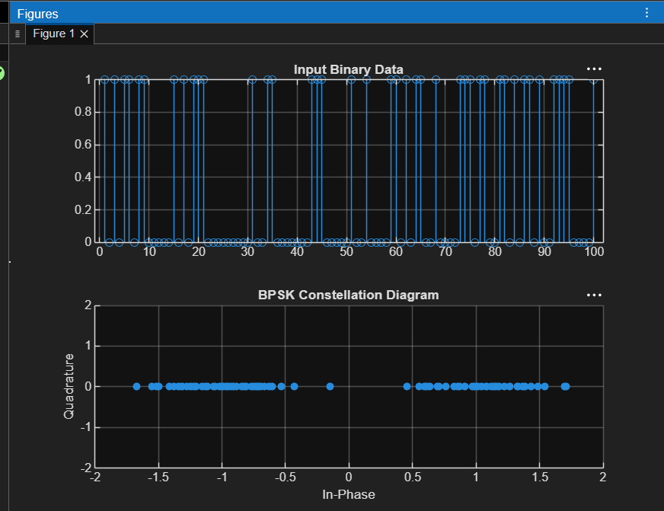
Figure 1: Input binary data and BPSK constellation diagram with AWGN.
4. Simulation Parameters
Parameter | Value
Number of bits (N) | 100
Bit generation | randi([0 1],N,1)
BPSK mapping | 0 → −1, 1 → +1
Channel model | AWGN
Signal-to-noise ratio | 10 dB
Constellation axes | In-Phase and Quadrature
5. Applications
- Digital wireless communication links that require robust binary data transmission.
- Satellite and deep-space communication links where noise performance is important.
- Digital telemetry and data transmission systems.
- Teaching and evaluating digital modulation using constellation diagrams.
6. Alignment with Analog and Digital Communication
This experiment covers digital data generation, BPSK symbol mapping, AWGN channel modelling and constellation-diagram analysis. It demonstrates how channel noise changes the received symbol locations and provides a visual way to understand the separation between the two BPSK symbol states.
ADC Concept | Implementation | Observed Output
Binary data generation | randi([0 1],N,1) | Input Binary Data
BPSK mapping | 2*bits - 1 | Symbols at −1 and +1 ideally
AWGN channel | awgn(bpsk,10,'measured') | Noisy received symbols
Constellation analysis | scatter(real(rx),imag(rx),'filled') | BPSK Constellation Diagram
7. Justification
- Random binary input provides a data sequence for the modulation process.
- BPSK maps each bit to one of two opposite phase states, represented here by −1 and +1.
- AWGN models noise that can affect symbol detection at the receiver.
- The constellation diagram visualizes received symbols and the spread caused by noise.
- The two-state BPSK representation makes it easier to study symbol separation and noise tolerance.
8. Conclusion
BPSK modulation was simulated in MATLAB using a random binary sequence. AWGN was added at an SNR of 10 dB, and the received symbols were displayed using a constellation diagram. The plot shows two groups of received points around the ideal BPSK symbol locations, illustrating the effect of noise on a digital communication signal.
DONE BY
Lokesh A
Register Number: 192512293
B.E. Electronics and Communication Engineering (ECE)

